Strategic Collaboration announced by Two Eye Bank Leaders –
Vision Share, Inc. and KeraLink International
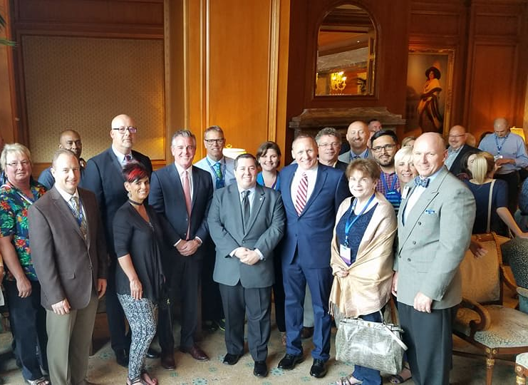
SALT LAKE CITY, UTAH, June 16, 2017 –Vision Share, Inc. and KeraLink International announced their new cooperative tissue sharing agreement designed to significantly increase the availability of transplantable ocular tissue grafts to surgeons worldwide, during the Eye Bank Association of America’s 56th Annual Meeting in Salt Lake City, Utah.
“As a first of its kind collaboration, KeraLink and Vision Share intend to work together to leverage our resources to more effectively serve our common missions. We are thrilled to work with a like-minded organization, KeraLink International, to reach more people in the U.S. and around the world,” said Vision Share’s President and CEO Philip I. Waitzman MBA, MPH, MA, LSW. Two of the largest providers of ocular tissue used to restore and maintain sight domestically and internationally, Vision Share and KeraLink seek to lead and redefine the relationship between surgeons and eye banks while promoting and honoring all donors’ legacies. Together, Vision Share and KeraLink have supply agreements with nearly half of the eye banks in the United States, and place over 40,000 surgical grafts each year.
The agreement will promote each organization’s access to the tissue needed by US and International surgeons to restore sight on any given day. With a unified strategy for maximizing the utilization of donor tissue, KeraLink and Vision Share will optimize the use of the tissue to restore sight. Both organizations have significant international outreach programs that will be strengthened by this collaboration. Vision Share and KeraLink International will work together to more efficiently deliver tissue to countries around the world where tissue is most needed. In addition, the number of corneas that may be discarded due to low cell counts or prolonged preservation times will be reduced, as those corneas can be more efficiently channeled into KeraLink’s proprietary VisionGraft® sterile processed cornea program. The collaboration also provides numerous opportunities for utilizing non-surgical tissue for research and training. “Vision Share has a robust training and development program which supplies tissue for research, wetlabs, conference seminars and other customized trainings. This agreement will continue to ensure that tissue utilization is maximized.” said Philip I. Waitzman.
The overall goal is to collectively provide more surgical tissue to physicians and make tissue available to researchers while also reducing the number of tissues being discarded. “We see this as a unique opportunity to make sure every surgeon and patient will have the tissue they need when they need it, which goes to the heart of our shared missions,” explains Douglas J. Furlong, KeraLink International’s President and CEO. “In addition, our VisionGraft® program will provide an outlet to beneficially use even more ocular tissue which otherwise may have been discarded. This type of constructive collaboration among leading eye banks is what donor families have every right to expect, and we’re delighted to make it a reality.”

For more information, please contact:
Douglas J. Furlong
President & CEO
KeraLink International
5520 Research Park Drive, Suite 400
Baltimore, MD 21228
Phone: 443-498-0098
Email: dfurlong@KeraLink.org

Or

Philip I. Waitzman MBA, MPH, MA, LSW
President & CEO
Vision Share, Inc.
111 N. Wabash, Suite 1300
Chicago, IL 60602
Phone:312.624.3937
Email: pwaitzman@visionshare.org

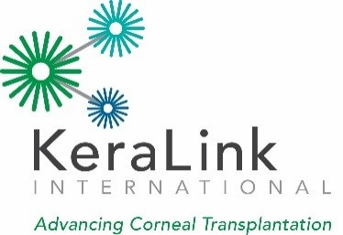
KeraLink International is a non-profit, non-governmental network of eye banks and related programs committed to reversing corneal blindness wherever it exists. The organization accomplishes this by investing in world-class facilities, medical education, collaboration with other members of the transplant community, creative development campaigns and cutting-edge research, as well as by providing charitable tissue both domestically and internationally to patients in need. KeraLink International is proud that its cooperative relationships with multiple Organ Procurement Organizations and other eye banks allow it to extend its reach. With seven processing centers strategically located throughout the United States, KeraLink International is positioned to process and deliver high quality tissue to surgeons and their patients. In addition, KeraLink’s international arm, the International Federation of Eye Banks (IFEB), provides support, oversight and innovative programming assistance to 29 IFEB members around the world.
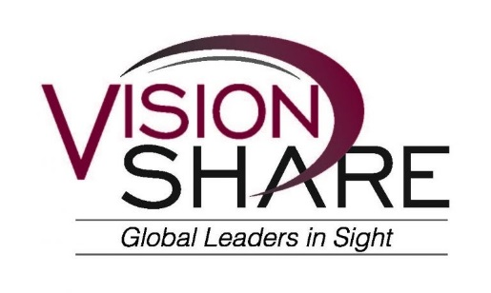
Vision Share is the largest network of eye banks in the world, spanning over 20 states in the U.S. Vision Share is a non profit organization, and its members are consistently recognized as among the best in class for eye bank experience and expertise and are leading innovators in eye bank procedures and technology. Vision Share’s network of eye banks provide the opportunity to meet local, national, and international eye tissue needs for tissue recovery, sight restoration and research. Additionally, as an industry leader, Vision Share provides expertise, knowledge and education for the purpose of improving the eye banking and Ophthalmic industries. Vision Share prides itself on having a global reach for placement of eye tissue. Its network and its reach are designed to meet the specific individual needs of surgeons, hospitals, surgery centers, academic institutions, and other eye banks in need of ocular tissue and related services regardless of location.

